Name: Tess Heber Date: December 2, 2020

Graded Assignment
Unit Test, Part 2
This chemistry test will be completed by answering the questions below. Once you have completed typing your answers into this document, please submit the file to the correct assignment folder in your course. The assignment needs to be submitted as a Word document and must be submitted by the due date. If needed, you may draw the graph by hand, take a picture of the graph, and incorporate into this Word file.
(10 points)

- The table below shows the pressures of a gas when the temperature is changed. Plot the data on the graph below. Draw a trend line that goes through the data.

Pressure of Gas with Changes of Temperature

Temperature (°C) | Pressure (torr)
10 | 530
25 | 585
55 | 720
70 | 760
90 | 815

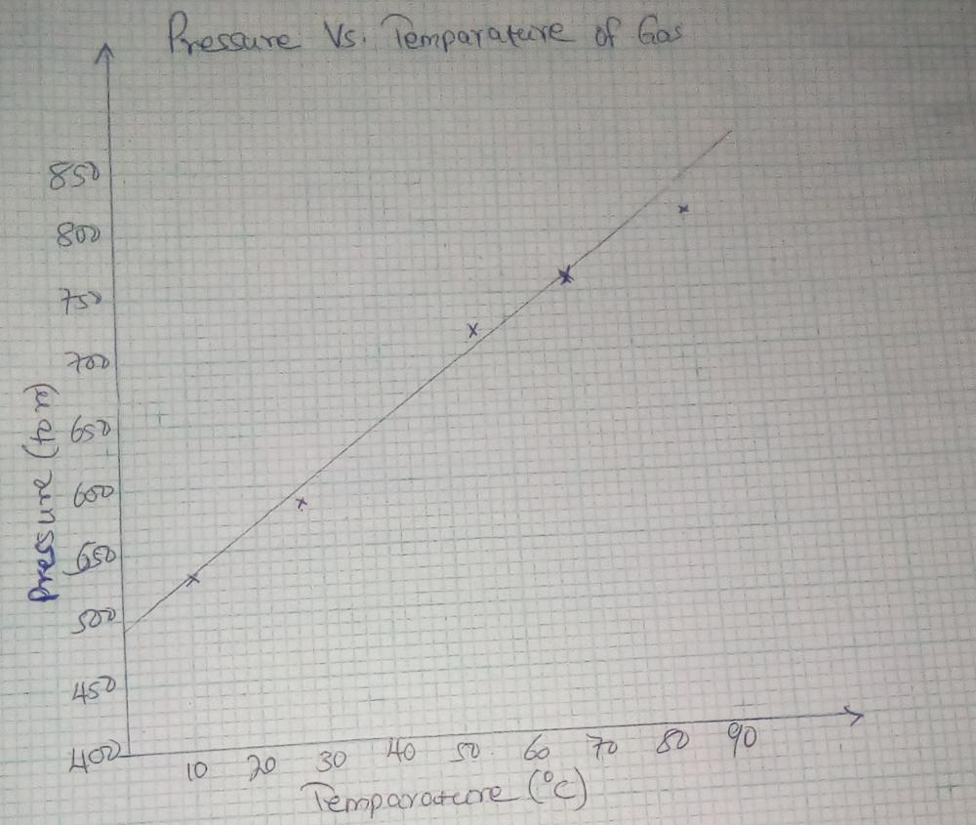

- Calculate the slope of the trend line (show your work). Make sure to include units for the slope.
Slope= change in y/ change in x
= (760-720)/ (70-55)
= 40/15
= 2.67

- Explain how the variables of temperature and pressure are related.
Increase in temperature results to increase in pressure proportionately and decrease in temperature will result to a decrease in pressure proportionately.
- Use the trend line to determine what will be the gas pressure at 0°C?

490 torr

(5 points)

- You are completing a lab where you are to calculate the density of an irregularly shaped object. You measure the mass of the object as 3.1 x 104 kg. You then use water displacement to determine the volume and get a value of 1.9 m3. In performing the following calculations, all work must be shown for credit!
  - Convert the mass of the object to g.
1kg = 1000g
Therefore, 3.14 × 10⁴ =3.1 × 10⁴ × 1000
= 3.14 × 10⁷g

  - Convert the volume of the object to cm3.
1m³ = 1000000cm^{3.} This implies that 1m³= 10⁶cm³
Therefore, 1.9m³ = 1.9 × 10⁶cm³

  - Calculate the density of the object in units of g/cm3. Make sure to give your answer with the correct number of significant figures and put your answer in proper scientific notation.
Density= Mass/Volume
3.1 × 10⁷/ 1.9 × 10⁶
=1.63 × 10¹
=16.3g/cm³

(5 points)

- Melissa has a new car and in checking the engine, she finds that the antifreeze level is low. Car antifreeze is a mixture of water and another substance, commonly methanol, ethylene glycol, or another low freezing-point liquid. The antifreeze she has contains methanol and needs to be mixed with water before being placed into the car. Melissa does some research and reads that a 50: 50 mixture of methanol and water is not only best for keeping a car’s radiator from freezing, but it will also take a higher temperature to make the car’s radiator boil over.
  - Design an experiment to test the statement that a 50: 50 mixture of methanol and water most effective for use in the radiator. Please write a hypothesis and clearly define your variables. Explain the procedure that you would use.
Basically, antifreeze is a liquid that is tinted and is put together with water in the radiator to assist in regulating the temperature of the engine. Ethylene glycol which is its key ingredient lowers the freezing point of water as well as raising its boiling point. This assists to prevent the water in the radiator from evaporating, boiling of freezing.
Together with oil and fuel, antifreeze is critical to a better operating engine. Without it, the combustion heat would make the engine to overheat rapidly or even seize up completely. It will also be responsible on rubricating the components of the cooling system which come into contact with water and will prevent metal components from corroding. Water only will not be enough to cool the engine since the heat from combustion will make it boil over eventually.
When changing the antifreeze, I will allow the engine and the radiator to cool for at least an hour and then open the hood to inspect the hoses and the radiator where the parts that are damaged will require to be repaired or replaced. From there, I will remove the radiator cap and loosen the drain plug of the radiator and drain the coolant and then tighten the plug and refill the radiator with distilled water and run the engine for around ten minutes. Then, topping off with more distilled water, I will refill the radiator with radiator flush. I will repeat this procedure until the water when draining runs clear. The last step will be to fill the radiator with a mixture of 50:50 of distilled water and antifreeze and replace the cap of the radiator.

